**RIT Dubai**

**CSEC 462-Network Security and Forensics**

**Spring 2025**

**LAB Practice Netflow**

|  | **Name** | **ID** |
| --- | --- | --- |
| **1** | Rania Kanaan | 769007321 |
| **2** | Fatima Mansur Rabiu | 776006447 |
| **3** | Suhaila Alfalasi | 764005288 |
| **4** | Syed Shayan Ali | 393003651 |

**Objectives:**

In this lab, NSM tools are used to observe the behavior of the network in terms of sessions information, log files, and other NSM data. Netflow information, and Syslog and AAA logs are investigated to get some insights about the network operations.

**Deliverables and Rubrics:**

The rubrics of this lab are as follows:

1- Report is organized properly with suitable objectives and structure. The organization of the report should be as follows: (15%).

a. Cover page which contains Lab general information, Group information, and Rubrics.

b. Objectives and goals of this lab

c. After answering the question of “Lab25.3.10: Explore a NetFlow Implementation” lab and provide your own screenshots, then copy and paste the whole document in here.

d. After answering the question of “Lab25.3.11: Logging from Multiple Sources” lab and provide your own screenshots, then copy and paste the whole document in here.

e. Conclusion that provides a summary of the two labs above and discusses how the experience with these tools can help a security analyst in detecting attacks and malwares.

2- The report provides all the figures and screen shots that demonstrate the steps of using NSM tools and data that you have captured associated with discussion and clear answer to questions that are part of these Lab25.3.10 (45%)

3- The report provides all the figures and screen shots that demonstrate the steps of using NSM tools and data that you have captured associated with discussion and clear answer to questions that are part of these Lab25.3.11 (25%)

4- The summary or conclusion that provides a summary of the two labs above and discusses how the experience with these tools can help a security analyst in detecting attacks and malwares. (15%)

**Packet Tracer - Logging from Multiple Sources**

# **Objectives**

**Part 1: Use syslog to capture log files from multiple network devices**

**Part 2: Observe AAA user access logging**

**Part 3: Observe NetFlow information**

# **Background / Scenario**

In this activity, you will use Packet Tracer to view network data generated by syslog, AAA, and NetFlow.

# **Instructions**

## **Part 1: View Log Entries with Syslog**

### **Step 1: The syslog Server**

Syslog is a messaging system designed to support remote logging. Syslog clients send log entries to a syslog server. The syslog server concentrates and stores log entries. Packet Tracer supports basic syslog operations and can be used for demonstration. The network includes a syslog server and syslog clients. R1, R2, Core Switch, and the Firewall are syslog clients. These devices are configured to send their log entries to the syslog server. The syslog server collects the log entries and allows them to be read.

Log entries are categorized by seven severity levels. Lower levels represent more serious events. The levels are: emergencies (0), alerts (1), critical (2), errors (3), warnings (4), notifications (5), informational (6), and debugging (7). Syslog clients can be configured to ship log entries to syslog servers based on the severity level.

a. Click the **Syslog Server** to open its window.

b. Select the **Services** taband select **SYSLOG** from the list of services shown on the left.

c. Click **On** to turn on the Syslog service.

d. Syslog entries coming from syslog clients will be shown in the window on the right. Currently, there are no entries.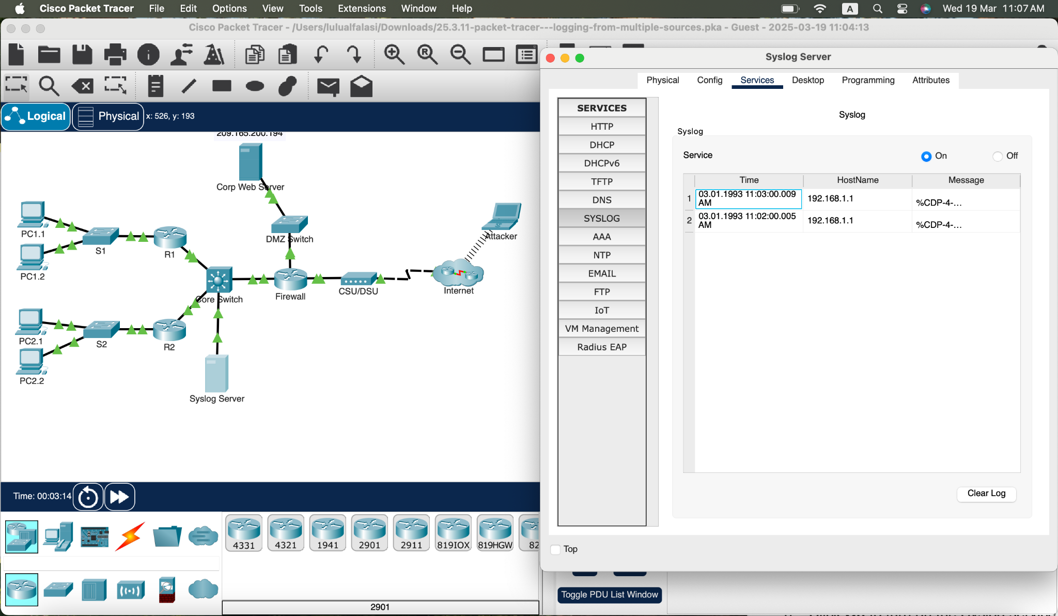

Figure 1. Syslog Entries

e. Keep this window open and visible and move on to **Step 2**.

### **Step 2: Enable Syslog.**

The devices are already configured to send log messages to the syslog server, but Packet Tracer only supports the logging for the debugging severity level with syslog. Because of that, we must generate debug level messages (level 7) so they can be sent to the syslog server.

a. Click **R1** **> CLI** tab.

b. Press Enter to get a command prompt and enter the command **enable**.

c. Enter the command **debug eigrp packets** to enable EIGRP debugging. The command line console will immediately fill with debug messages.

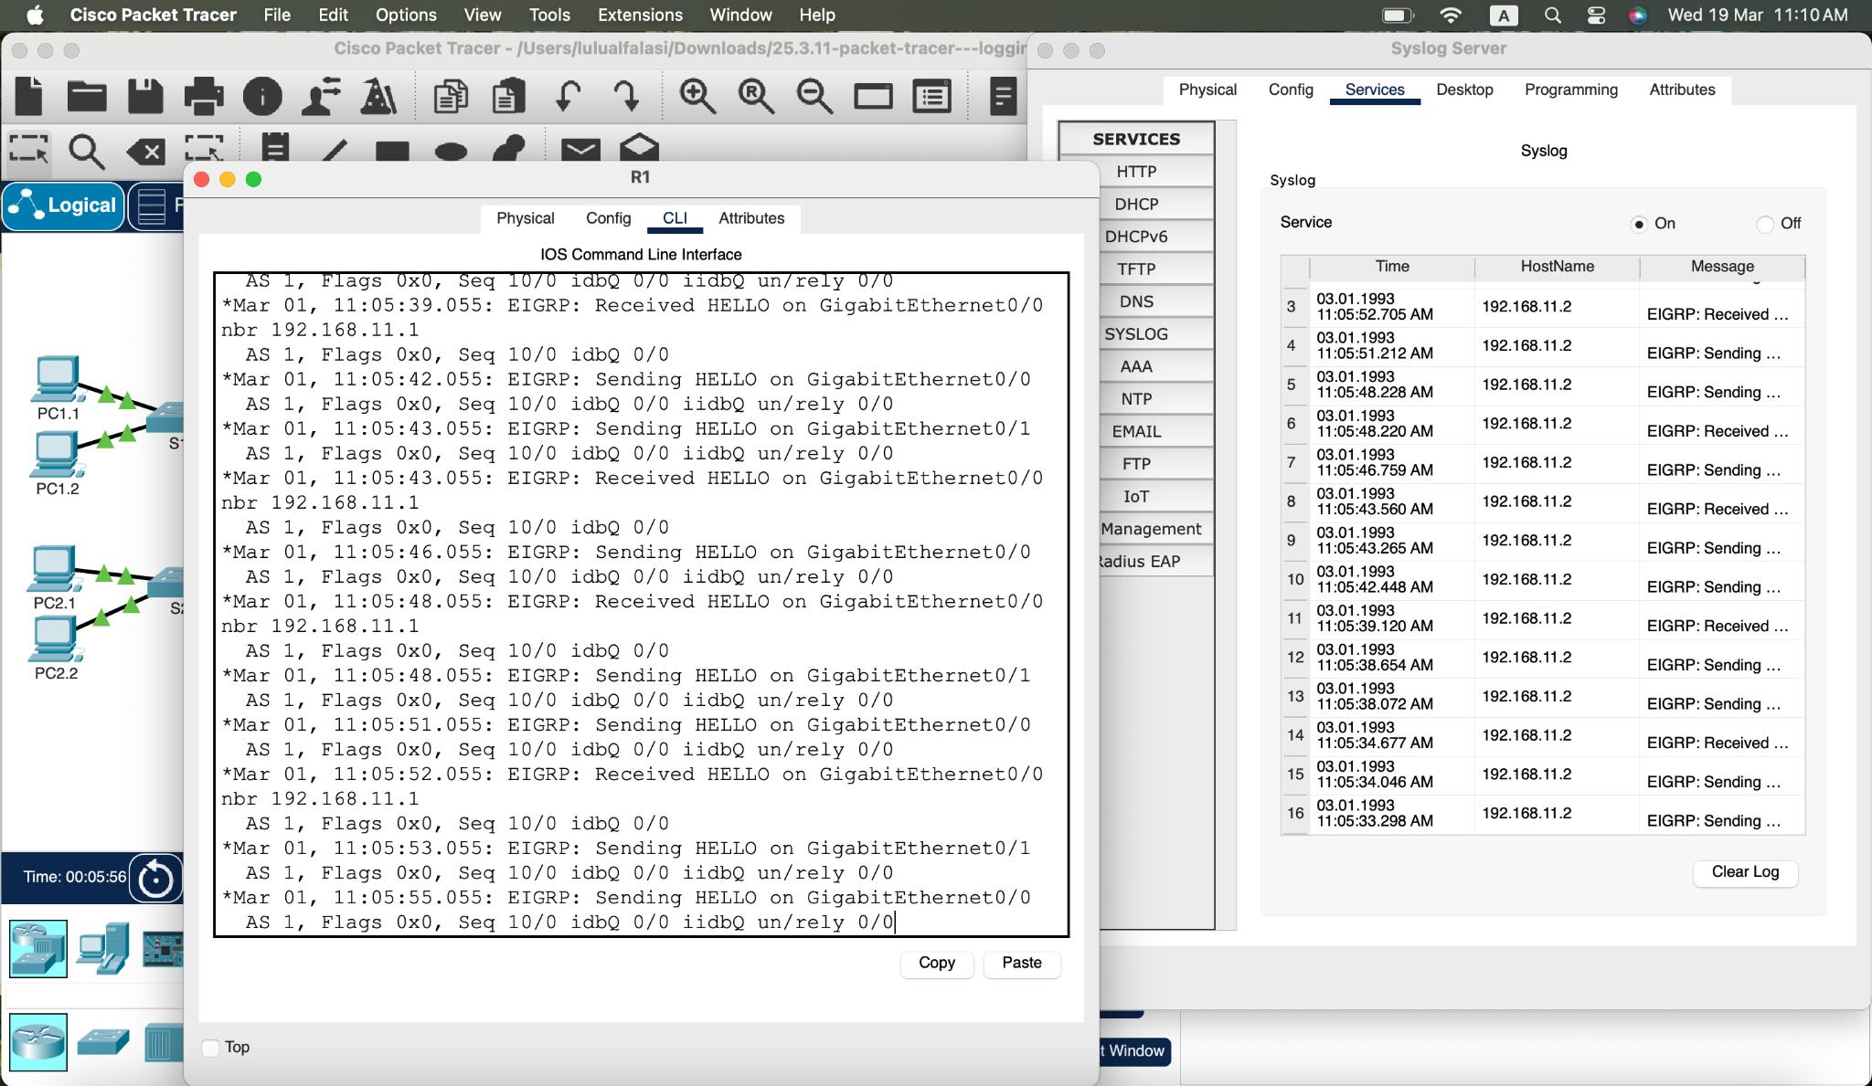

Figure 2. Debug Eigrp packets

d. Return to the **Syslog Server** window. Verify that log entries appear on the syslog server.

e. After a few messages have been logged, click the radio button to turn the syslog service **Off**.

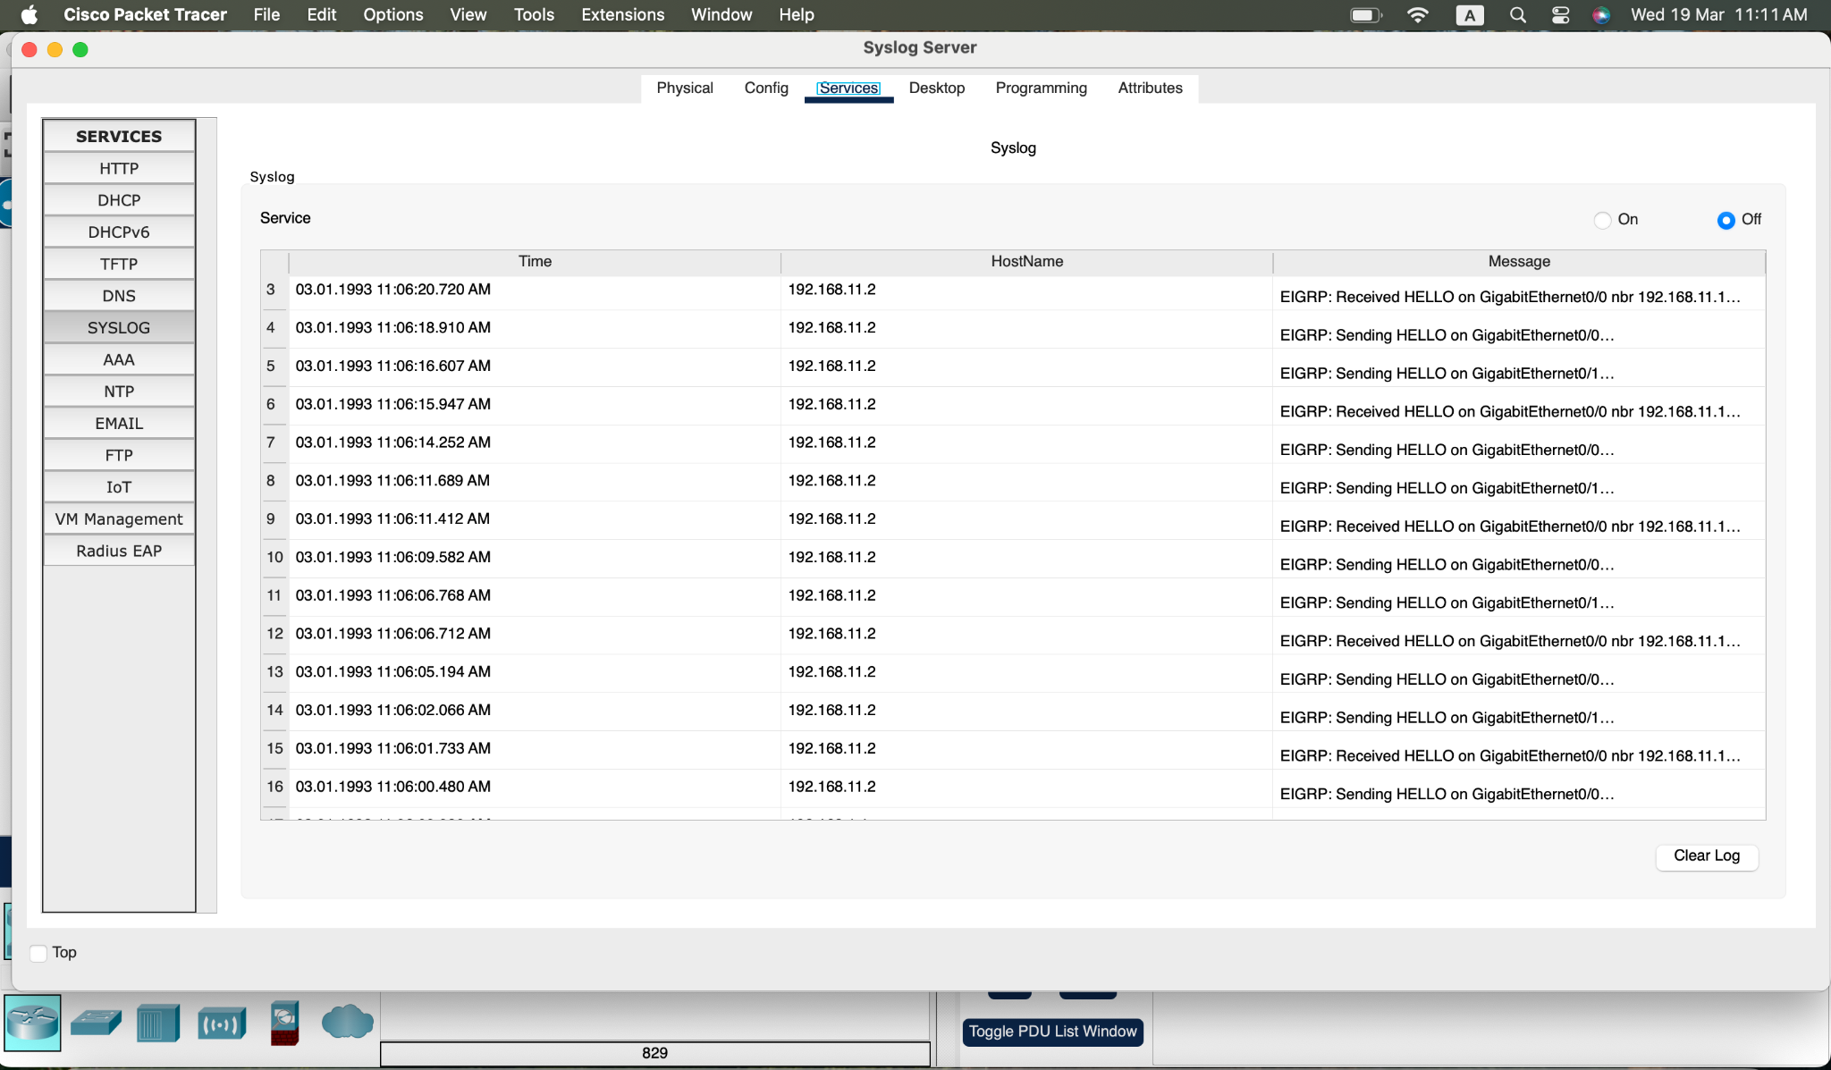

Figure 3. Syslog server Verification

#### Question:

What is some of the information that is included in the syslog messages that are being displayed by the Syslog Server?’

Some of the information displayed include timestamps that indicate when the event occurred, the hostname as the ip address and lastly the message which is the nature of event displayed as EIGRP packet debug meesssages including the routing updates and port

f. Close the **R1** device window.

## **Part 2: Log User Access**

Another important type of log relates to user access. Having records of user logins is crucial for troubleshooting and traffic analysis. Cisco IOS supports Authentication, Authorization and Accounting (AAA). With AAA, it is possible not only to delegate the user validation task to an external server but also to log activities.

TACACS+ is a protocol designed to allow remote authentication through a centralized server.

Packet Tracer offers basic AAA and TACACS+ support. R2 is also configured as a TACACS+ server. R2 will ask the server if that user is valid by verifying username and password, and grant or deny access based on the response. The server stores user credentials and is also able to log user login transactions. Follow the steps below to log in to R2 and display the log entries related to that login:

a. Click the **Syslog Server** to open its window.

b. Select the **Desktop** tab and select **AAA Accounting**. Leave this window open.

c. Click **R2 > CLI**.

d. Press Enter to get a command prompt. **R2** will ask for username and passwordbefore granting access to its CLI. Enter the following user credentials: **analyst** and **cyberops** as the username and password, respectively.

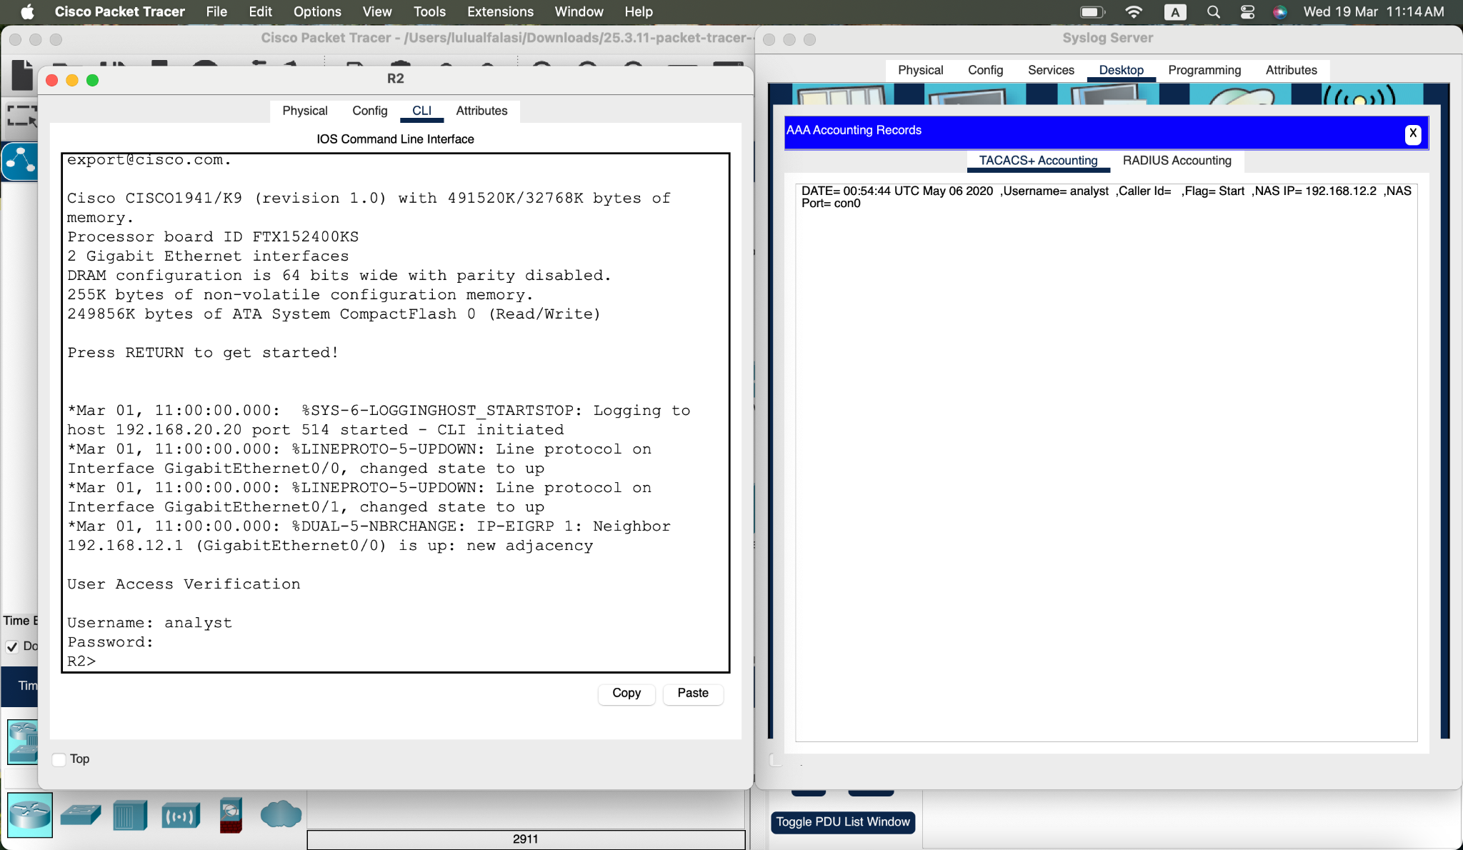

Figure 4. User Access Verification

e. Return to the Syslog Server’s AAA Accounting Records window.

#### Question:

What information is in the log entry?

The log entry shows the user that logged in with the name ‘analyst’, the timestamp of the event, the ip address and lastly the flag as start indicating a login

f. On R2, enter the **logout** command.

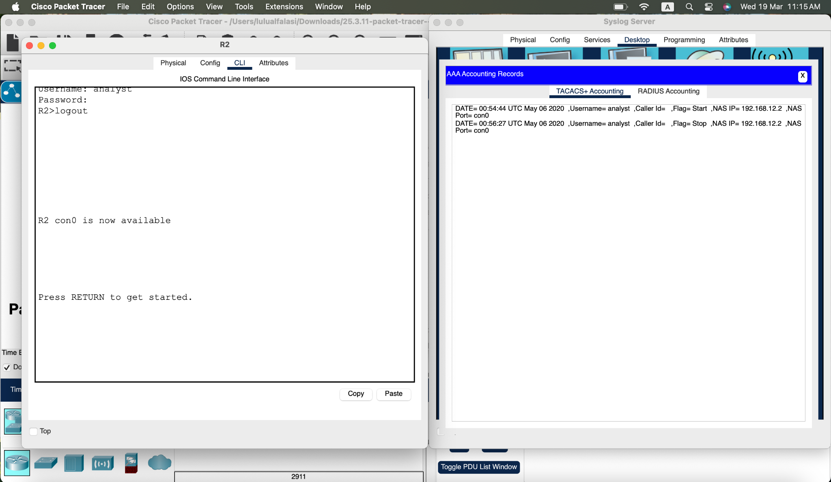

Figure 5. Logout command

#### Question:

What happened in the AAA Accounting window?

The AAA accounting window reflects the event of logout with the username ‘analyst’, the timestamp and the flag as stop indicating a system logout

## **Part 3: NetFlow and Visualization**

In the topology, the Syslog server is also a NetFlow collector. The firewall is configured as a NetFlow exporter.

a. Click the **Syslog Server** to bring up its window. Close the AAA Accounting Records window.

b. From the **Desktop** tab, select **Netflow Collector**. The NetFlow collector services should be turned on.

c. From any PC, ping the Corp Web Server at 209.165.200.194. After a brief delay, the pie chart will update to show the new traffic flow.

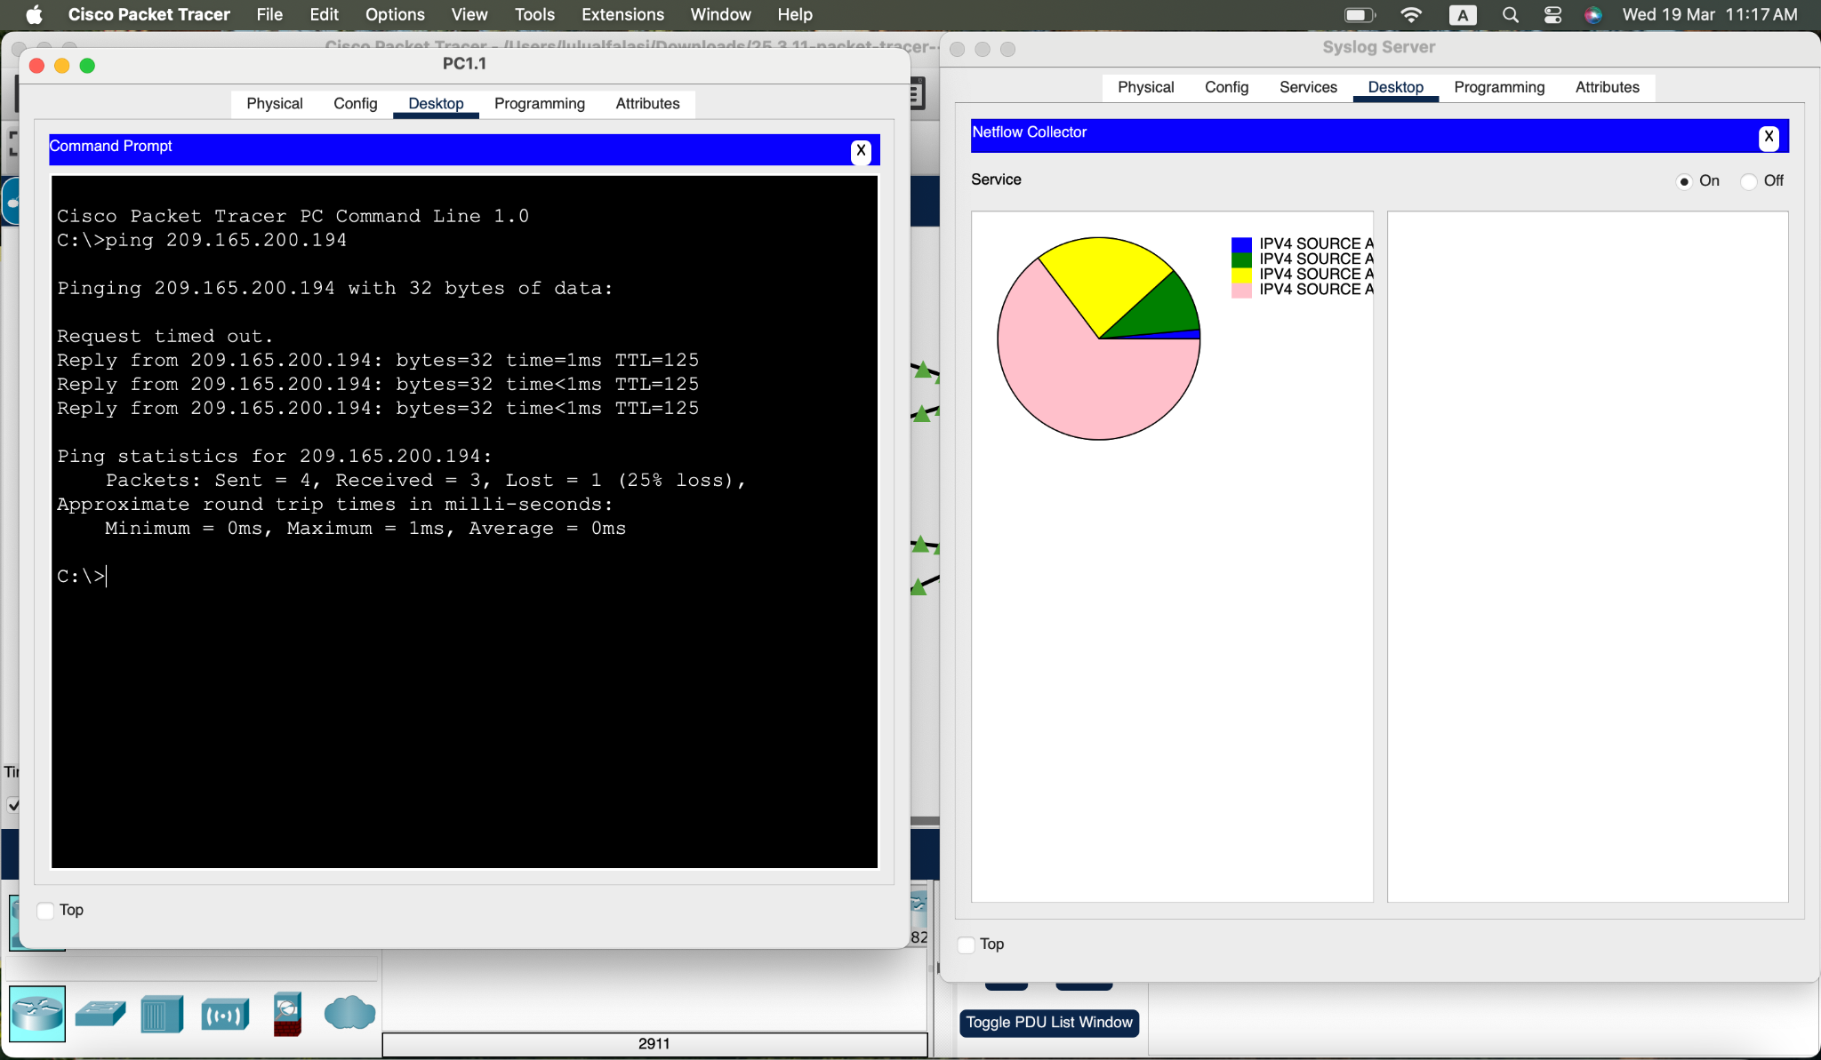

Figure 6. Pinging 209.165.200.194 piechart

**Note**: The pie charts displayed will vary based on the traffic on the network. Other packets flows, such as EIGRP-related traffic, are being sent between devices. NetFlow is capturing these packets and exporting statistics to the NetFlow Collector. The longer NetFlow is allowed to run on a network, the more traffic statistics will be captured.

# **Reflection**

While the tools presented in this activity are useful, each one has its own service and may need to run on totally different devices. A better way, explored later in the course, is to have all the logging information be concentrated under one tool, allowing for easy cross-reference and powerful search capabilities. Security information and event management (SIEM) platforms can gather log files and other information from diverse sources and integrate the information for access by a single tool.

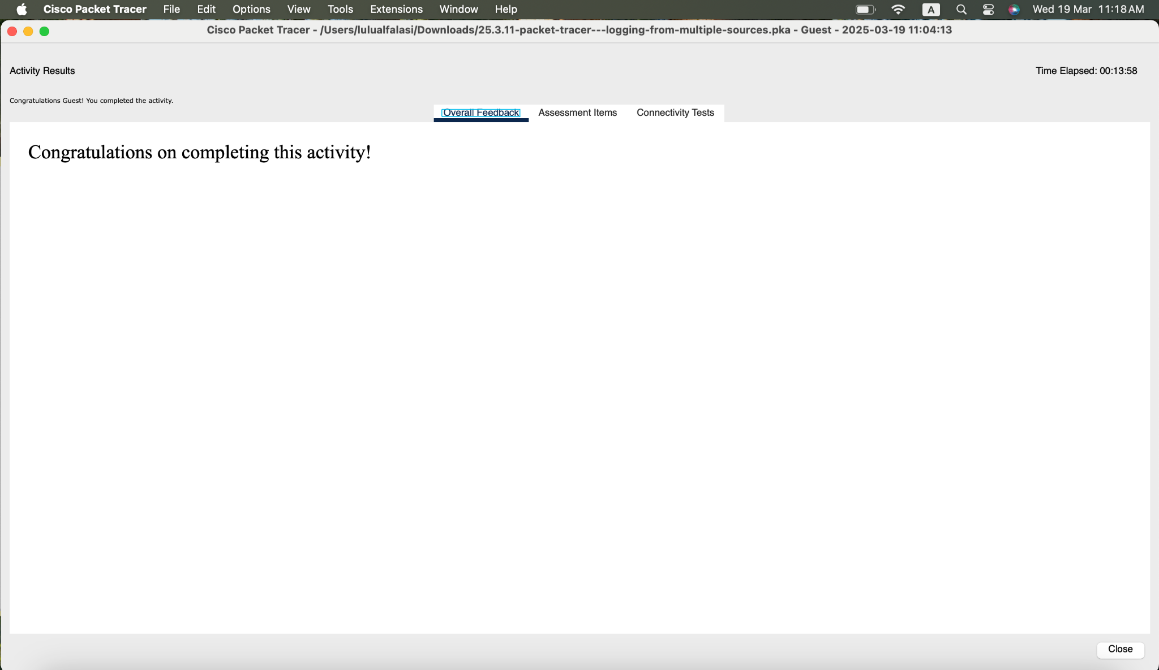

Figure 7. Verification of Completing the work

**Packet Tracer - Explore a NetFlow Implementation**

# **Objectives**

**Part 1: Observe NetFlow Flow Records - One Direction**

**Part 2: Observe NetFlow Records for a Session that Enters and Leaves the Collector**

# **Background / Scenario**

In this activity, you will use Packet Tracer to create network traffic and observe the corresponding NetFlow flow records in a NetFlow collector. Packet Tracer offers a basic simulation of NetFlow functionality. It is not a replacement for learning NetFlow on physical equipment. Some differences may exist between NetFlow flow records generated by Packet Tracer and by records created by full-featured network equipment.

# **Instructions**

## **Part 1: Observe NetFlow Flow Records - One Direction**

### **Step 1: Open the NetFlow collector.**

a. From the NetFlow Collector, click the **Desktop** tab. Click the **Netflow Collector** icon.

b. Click the **On** radio button to activate the collector as necessary. Position and size the window so that it is visible from the Packet Tracer topology window.

### **Step 2: Ping the default gateway from PC-1.**

a. Click **PC-1**.

b. Open the **Desktop** tab and click the **Command Prompt** icon.

c. Enter the **ping** command to test connectivity to the default gateway at 10.0.0.1.

C:\> **ping 10.0.0.1**

d. After a brief delay, the NetFlow Collector screen will display a pie chart.

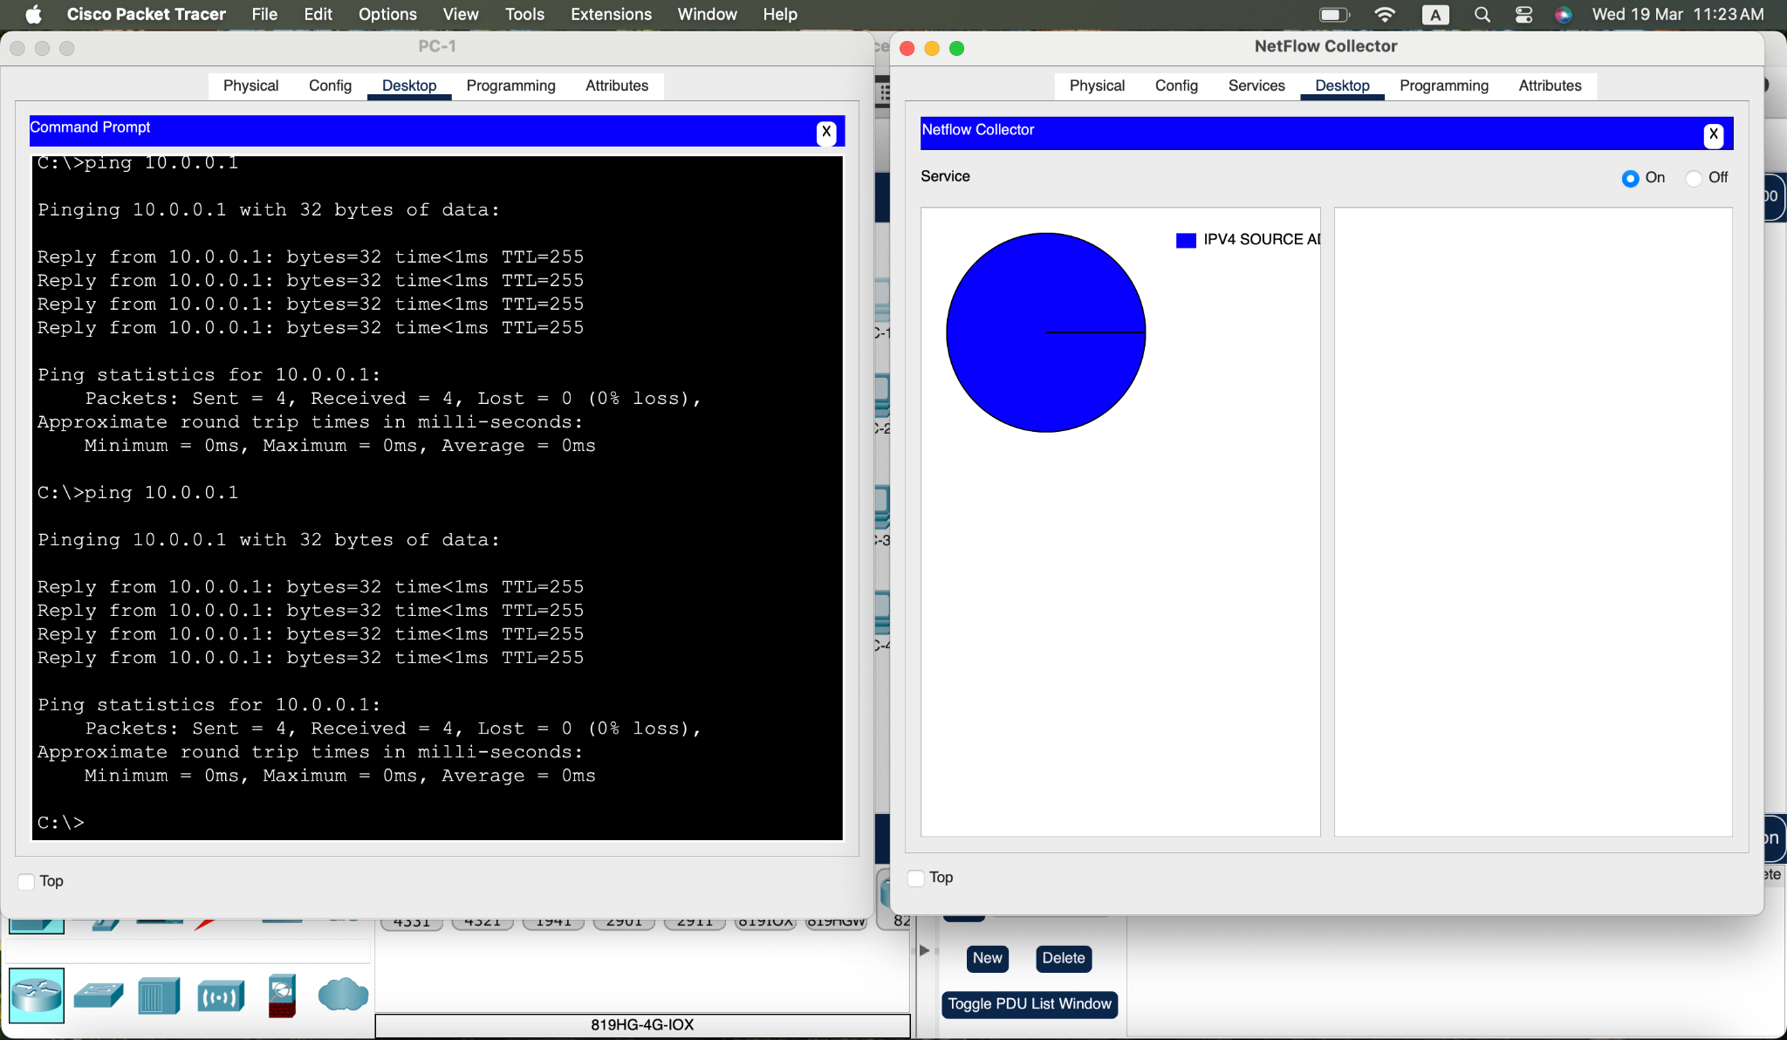

Figure 8. Pinging gateway piechart

**Note**: The first set of pings may not be sent to the NetFlow Collector because the ARP process must first resolve IP and MAC addresses. If after 30 seconds, a pie chart does not appear, ping the default gateway again.

e. Click either the pie chart or the legend entry to display the flow record details.

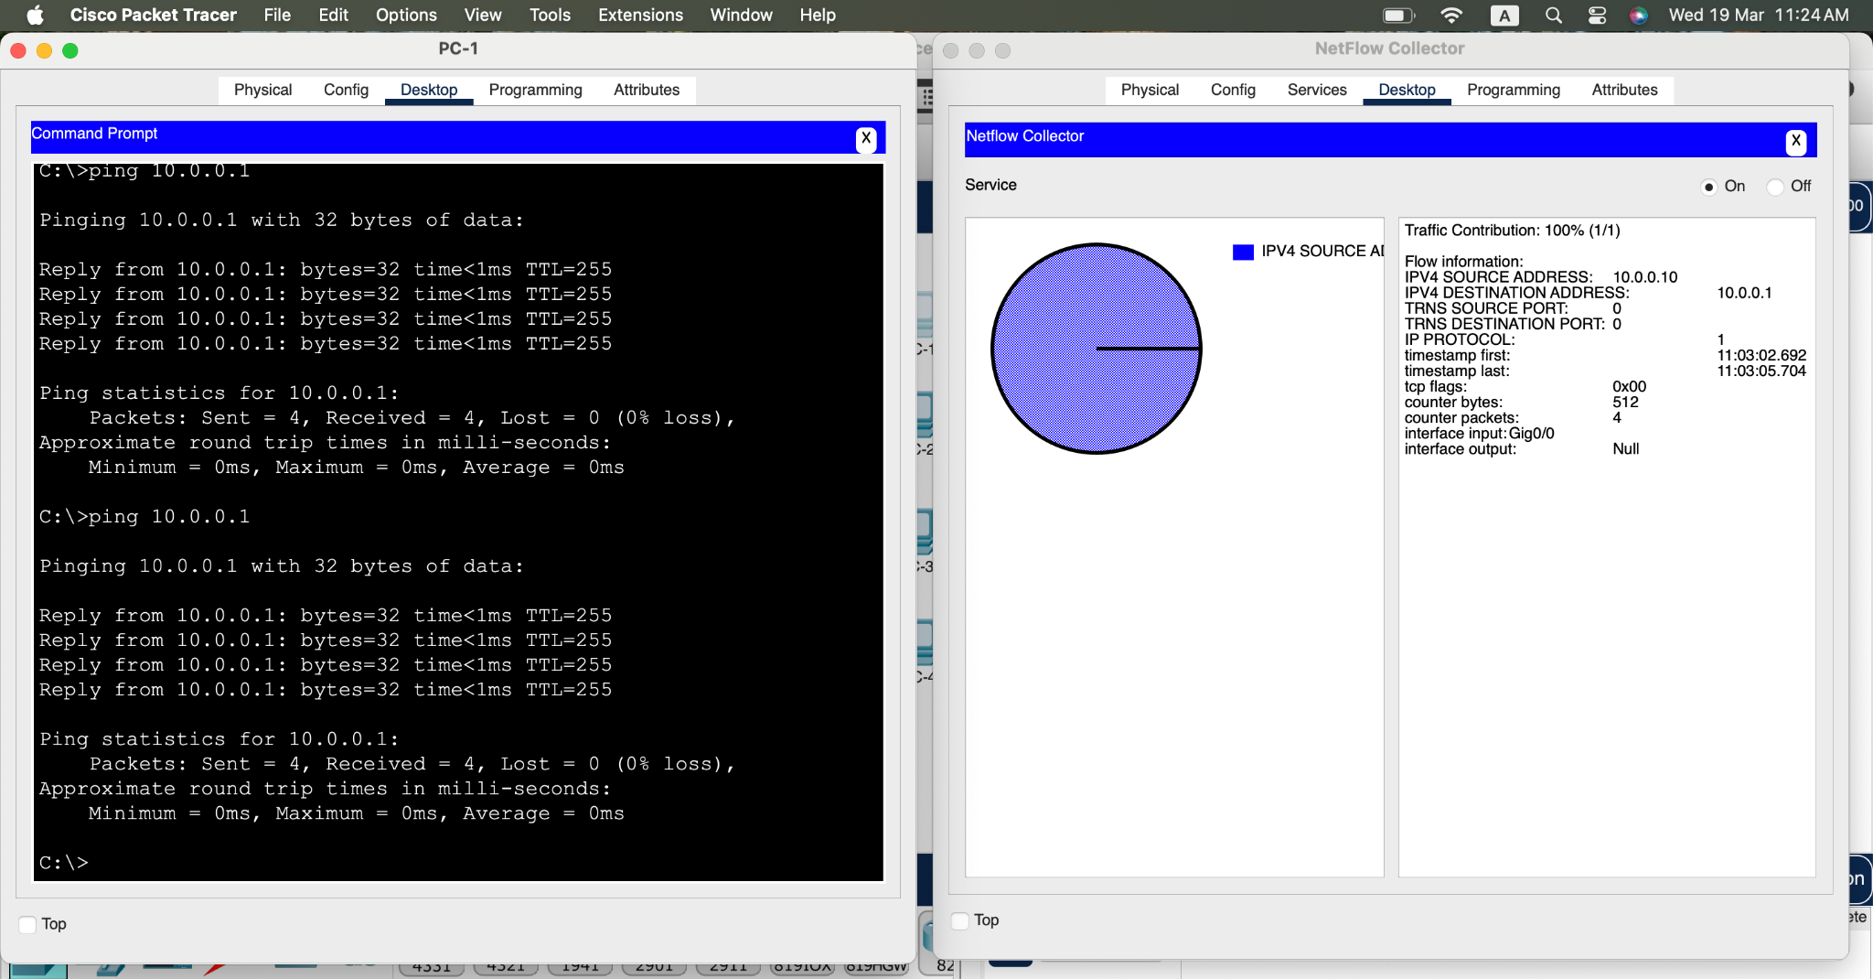

Figure 9. Gateway piechart details

f. The flow record will have entries similar to those in the table below. Your timestamps will be different.

| **Entry** | **Value** | **Explanation** |
| --- | --- | --- |
| Traffic contribution | 100% (1/1) | This is the proportion of all traffic represented by this flow. |
| IPV4 SOURCE ADDRESS | 10.0.0.10 | This is the source IP address of the flow packets. |
| IPV4 DESTINATION ADDRESS | 10.0.0.1 | This is the destination IP address of the flow packets. |
| TRNS SOURCE PORT | 0 | This is the transport layer source port. The value is 0 because this is an ICMP flow. |
| TRNS DESTINATION PORT | 0 | This is the transport layer destination port. The value is 0 because this is an ICMP flow. |
| IP PROTOCOL | 1 | This identifies Layer 4 service, typically 1 for ICMP, 6 for TCP, and 17 for UDP. |
| timestamp first | 00:47:49.593 | This is the timestamp for the beginning of the flow. |
| timestamp last | 00:47:52.598 | This is the timestamp for the last packet in the flow. |
| tcp flags | 0x00 | This is the TCP flag value. In this case, no TCP session was involved because the protocol is ICMP. |
| counter bytes | 512 | This is the number of bytes in the flow. |
| counter packets | 4 | This is the number of packets in the flow. |
| interface input | Gig0/0 | This is the interface of the flow exporter that collected the flow in the input direction (into the monitoring device interface). |
| interface output | Null | This is the interface of the flow exporter that collected the flow in the output direction (out of the monitoring device interface). The value is “Null” because this was a ping to the input interface. |

In this case, the flow represents the ICMP ping from host 10.0.0.10 to 10.0.0.1. Four ping packets were in the flow. The packets entered interface G0/0 of the exporter.

**Note**: In this activity, the Edge router has been configured as a NetFlow flow exporter. The LAN interface is configured to monitor flows that enter it from the LAN. The serial interface has been configured to collect flows that enter it from the internet. This has been done to simplify this activity.

To see traffic that matches a full bi-directional session, the NetFlow exporter would need to be configured to collect flows entering and leaving a network.

### **Step 3: Create additional traffic.**

a. Click **PC-2 > Desktop**.

b. Open a command prompt and **ping** the default gateway 10.0.0.1.

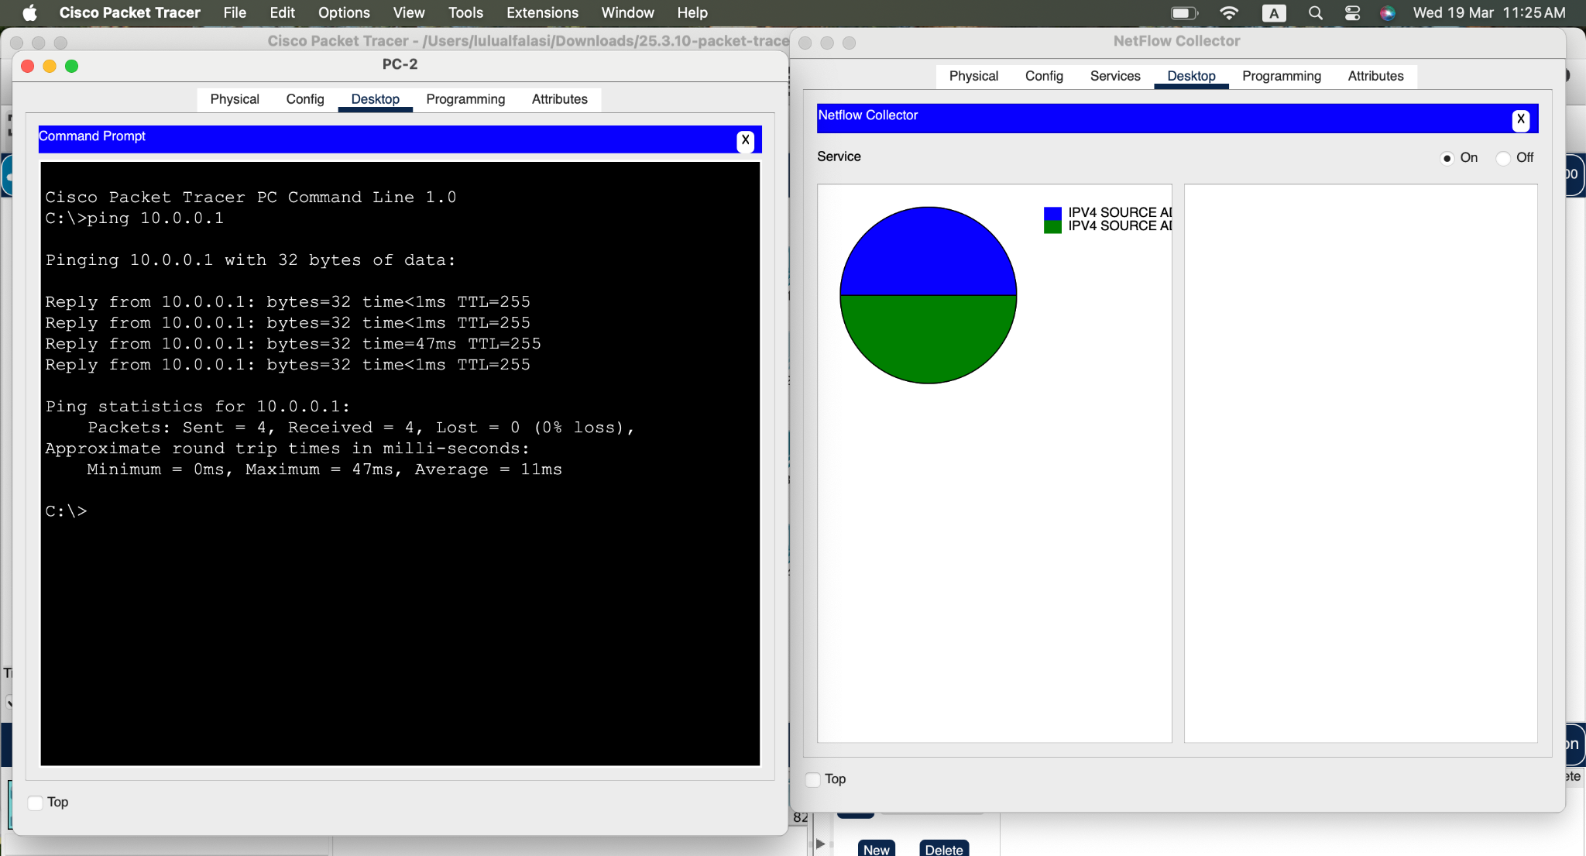

Figure 10. PC 2 Pinging Gateway piechart

#### Question:

What do you expect to see in the NetFlow collector flow records? Will the statistics for the existing flow record change, or will a new flow appear in the pie chart?

The PC-2 default gateway ping operations trigger a new entry to appear in the pie chart. The traffic analysis from NetFlow requires each combination of source IP, destination IP, source port and destination port and protocol parameters to function properly. Consistent IP allocation distinguishes the traffic since PC-2 works from IP address 10.0.0.11 and PC-1 functions from 10.0.0.10. Flow records related to PC-1 will remain unaffected and the pie chart will display separated sections between PC-1 and PC-2 traffic.

c. Return to PC-1 and repeat the ping to the gateway.

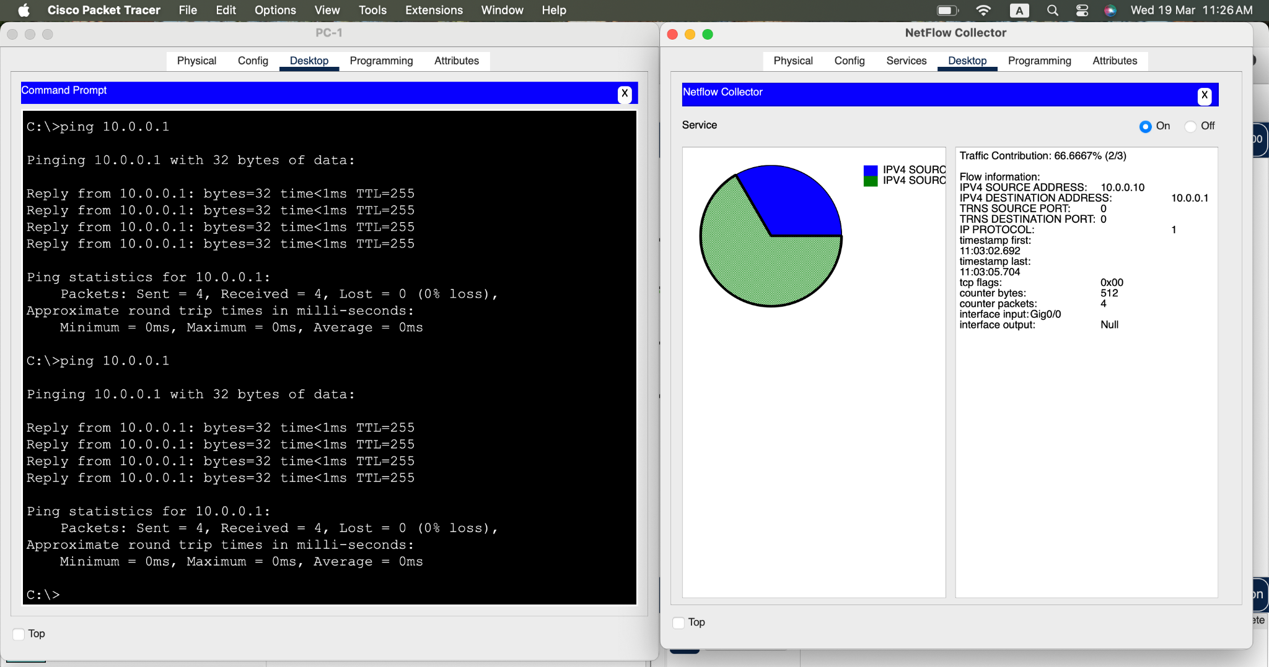

Figure 11. PC 1 Pinging Gateway piechart

#### Question:

How will this traffic be represented? As a new segment in the pie chart or will it modify the values in the existing flow record?

The repeating ping sent from PC-1 to the gateway makes changes to the existing flow record for PC-1. Multiplied values inside "counter bytes" and "counter packets" sections show the quantity of additional ping packets sent. The distribution between PC-1 and PC-2 segments remains unchanged as the pie chart's values will increase proportionally for PC-1's portion.

d. Issue pings from PC-3 and PC-4 to the default gateway address.

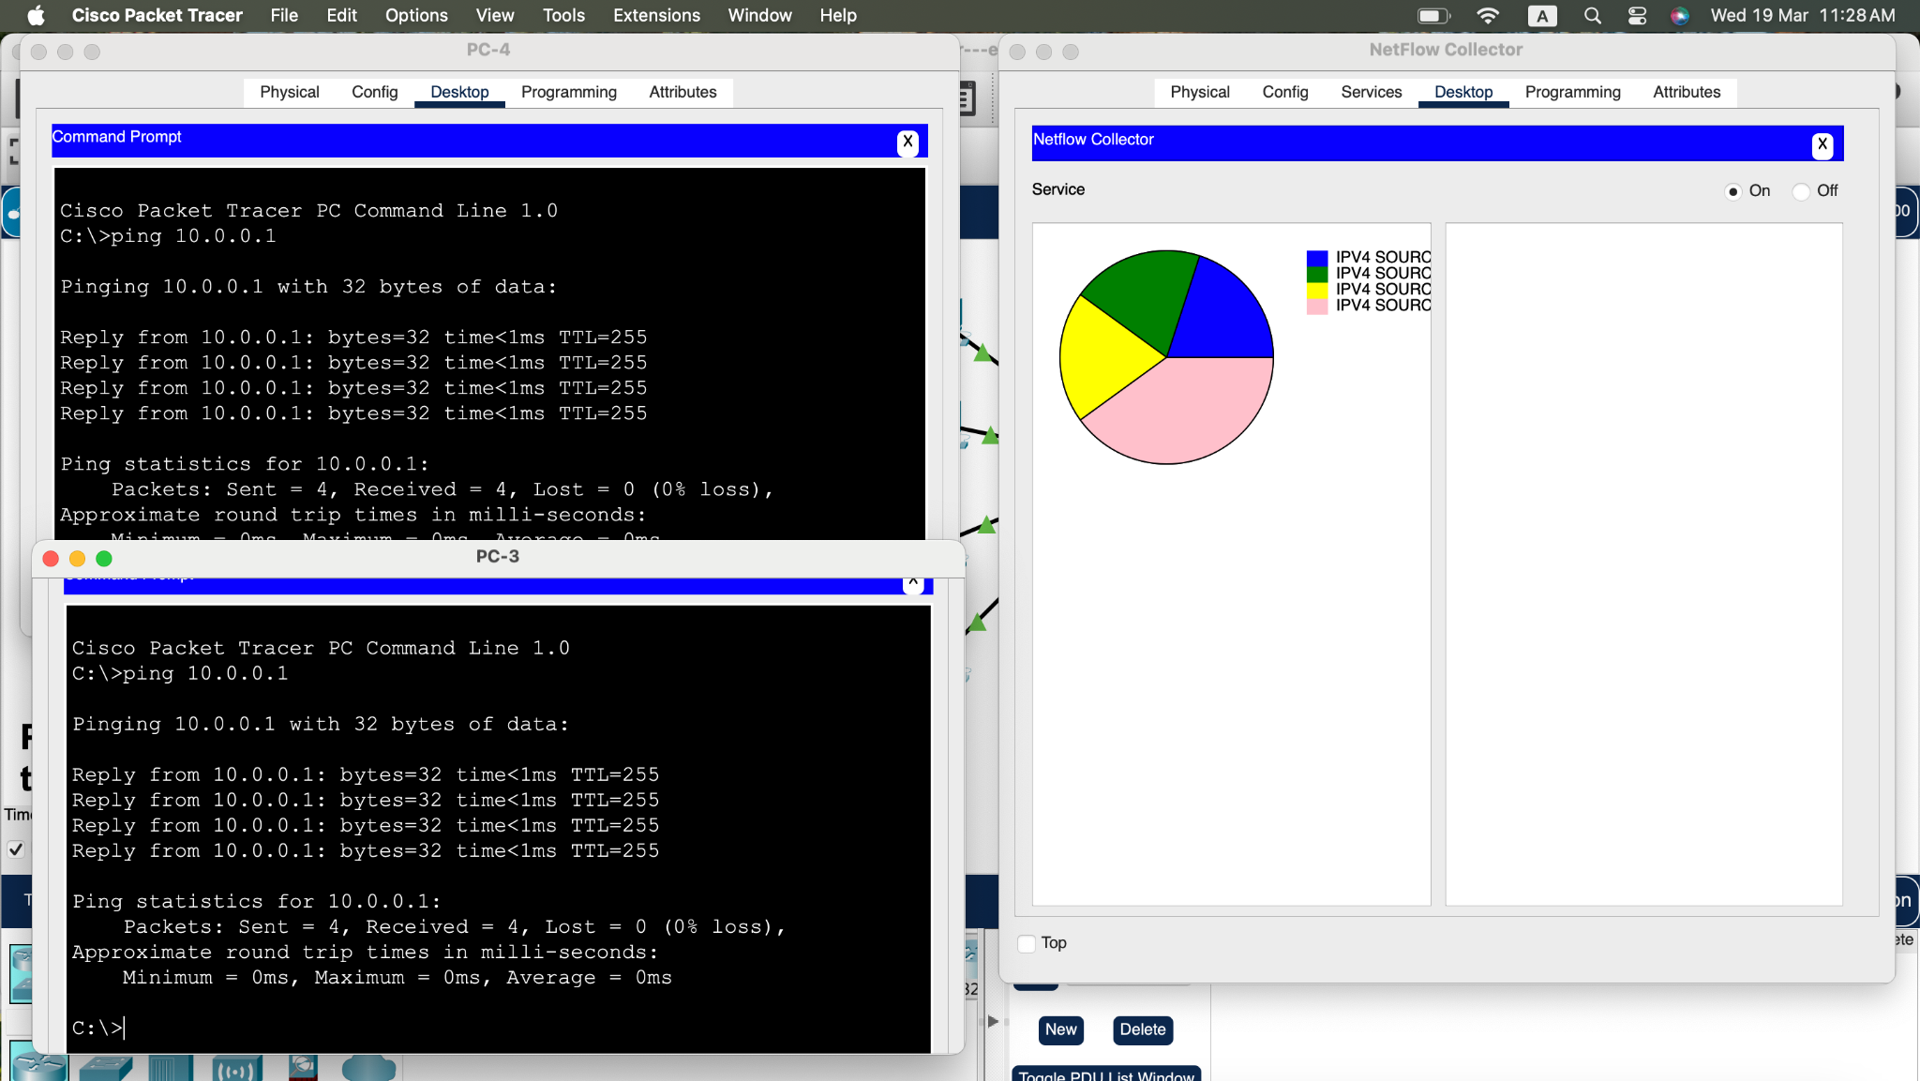

Figure 12. PC 3 and 4 Pinging Gateway piechart

What should happen to the display in the flow collector?

New segments will appear in the flow collector's pie chart for every pings sent from PCs 3 and 4 which adds separate sections for their IP sources PC-3 and PC-4. The flow collector displays separate segments for traffic that comes from each PC to reach the gateway. The existing segments for PC-1 and PC-2 will stay in the chart yet their visual size could adjust downward due to the increased number of traffic flows. The visual representation of traffic flow through the pie chart automatically updates its segments to show all existing and new traffic origins with their corresponding proportions to the complete network volume.

## **Part 2: Observe NetFlow Records for a Session that Enters and Leaves the Collector**

The NetFlow exporter has been configured to collect flows that exit the LAN and enter the router from the Internet.

### **Step 1: Access the Web Server by IP Address.**

Before continuing, power cycle the NetFlow Collector to clear the flows.

a. Click **NetFlow Collector > Physical** tab.

b. Click the red power button to turn off the server. Then click it again to turn the server back on. (**Note**: You may need to scroll over or zoom out.)

c. From the NetFlow Collector, click the **Desktop** tab.

d. Click the Netflow Collector icon. Click the “On” radio button to activate the collector. Close the NetFlow Collector window.

e. Before you access a web server from PC-1, predict how many flows will there be in the pie chart? Explain.

There will be two flows in the pie chart. When PC-1 accesses a web server by IP address, it initiates an HTTP request to the web server (destination port 80) and receives an HTTP response. NetFlow records flows based on unique combinations of source IP, destination IP, protocol, and port numbers. So you have two flows, one for the HTTP request and one for http response.

From your knowledge of network protocols and NetFlow, predict the values for the web page requests leaving the LAN.

| **Record Field** | **Value** | **Guidelines** |
| --- | --- | --- |
| Source IP address | *Blank* | N/A |
| Destination IP address | *Blank* | N/A |
| Source Port | 1025–5000 (MS Windows default, which is what PT uses. | This is an approximate value that is dynamically created. |
| Destination Port | *Blank* | N/A |
| Input Interface | *Blank* | N/A |
| Output Interface | *Blank* | N/A |

Predict the values for the web page reply entering the NetFlow exporter router from the internet.

| **Record Field** | **Value** | **Guidelines** |
| --- | --- | --- |
| Source IP address | *Blank* | N/A |
| Destination IP address | *Blank* | N/A |
| Source Port | *Blank* | N/A |
| Destination Port | 1025-5000 | This is whatever value was randomly assigned form the ephemeral port range. |
| Input Interface | *Blank* | N/A |
| Output Interface | *Blank* | N/A |

f. Click **PC-1 > Desktop**. Close the Command Prompt window, if necessary. Click the Web Browser icon.

g. In the Web Browser for PC-1, enter 192.0.2.100 and click **Go**. The Example Website webpage will display.

h. After a short delay, a new pie chart will appear in the NetFlow collector. You will see at least two pie segments for the HTTP request and response. You might see a third segment if the ARP cache for PC-1 timed out.

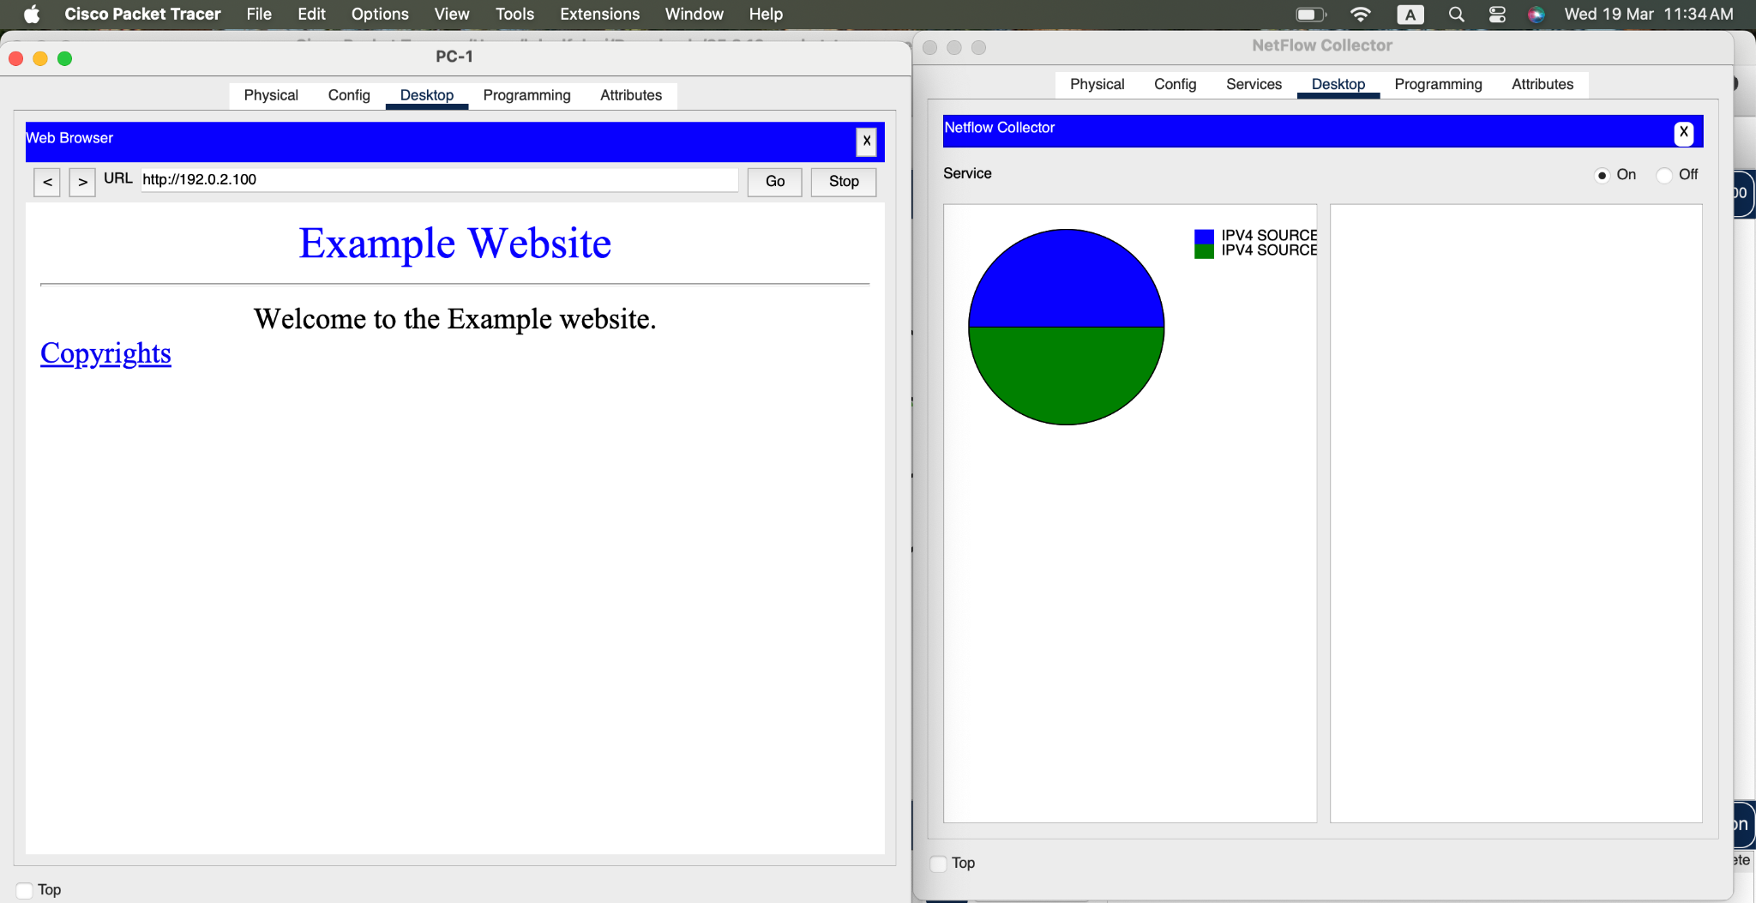

Figure 13. Searching 192.0.2.100 on Web Browser

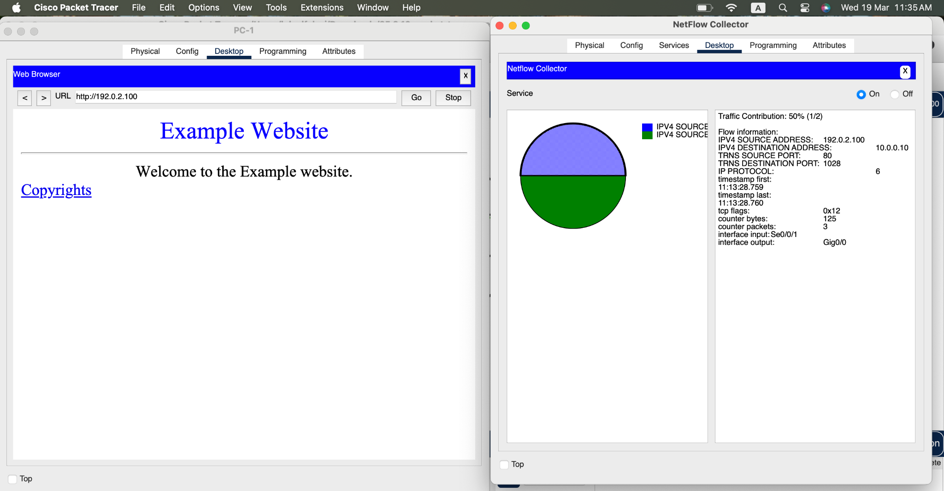

Figure 14. Web Browser piechart detail segment 1

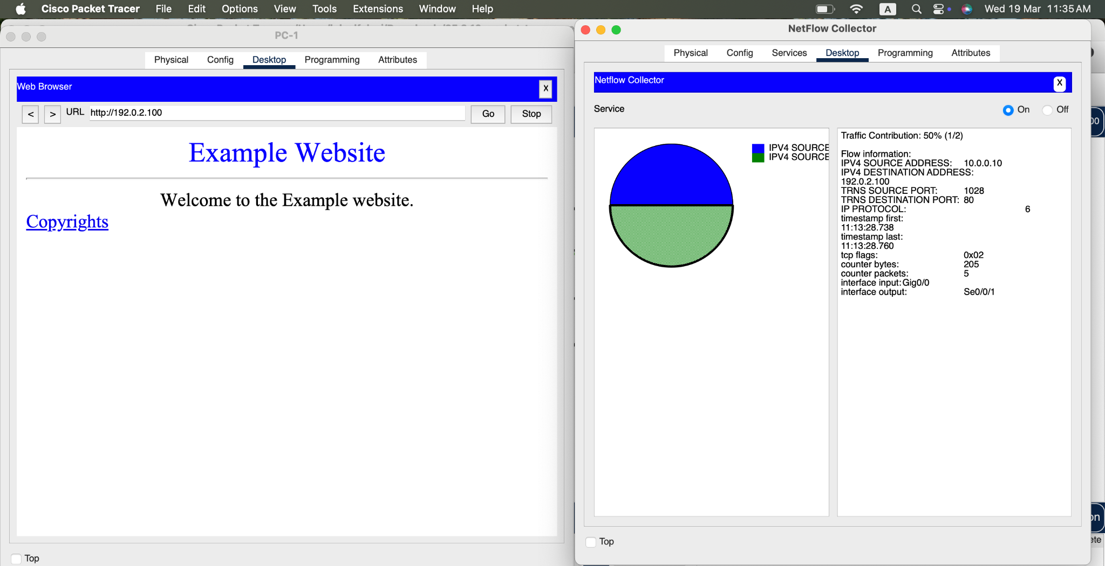

Figure 15. Web Browser piechart details segment 2

i. Click each HTTP pie segment to display the record and verify your predictions.

j. Click the link to the Copyrights page.

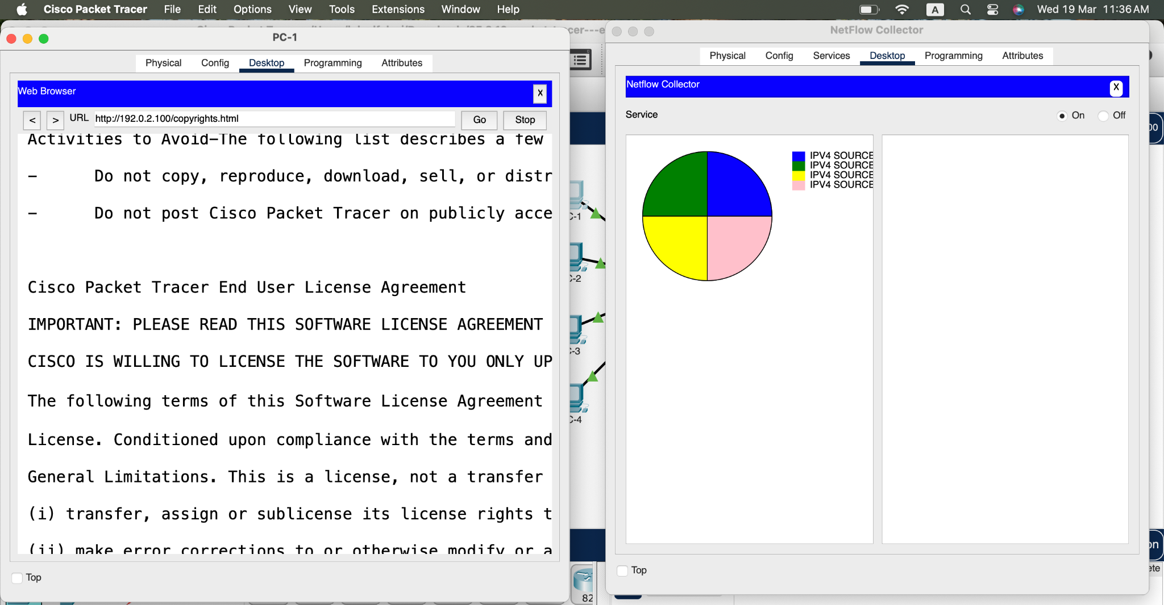

Figure 16. Copyright link piechart

#### Questions:

What happened? Explain. (Hint: compare the port number on the host for the flows.)

When the Copyrights link was clicked, a new HTTP request was sent from PC-1 to the web server. This created a new flow record in the NetFlow collector. Although the destination IP and port,which was 80,remained the same, the source port number on PC-1 changed, because modern systems assign a new source port for each new TCP session. Since NetFlow identifies flows based on the five tuples (source IP, destination IP, source port, destination port, and protocol), this slight change (which is the new source port) caused a new flow to be logged.

Compare the flows. Aside from the obvious timestamp, source and destination IP address, port, and interfaces, differences, what else is different between the request and response flows?

What’s different is thd direction of data flow and the corresponding byte and packet counts. So, the HTTP request flow (from PC-1 to the web server) typically contains fewer bytes and packets because it's just a request for a resource.The HTTP response flow (from the web server back to PC-1) contains significantly more data, as it includes the full web page content, images, or other resources — so its byte and packet counters are higher.Also, in some cases, TCP flags may differ. For example, response flows may include ACK or FIN flags, depending on the session state, which may not appear in the request flow if it’s just initiating the connection.

### **Step 2: Access the Web Server by URL.**

a. Power cycle the NetFlow Collector to clear the flows.

b. Turn on the Netflow Collector service.

c. Before you access the Web Server by its URL.

#### Question:

What do you think you will see in the NetFlow collector display?

The NetFlow collector has just been powered on and cleared, and no traffic has yet been generated. Since PC-1 has not made any DNS queries or HTTP requests, no flows exist in the collector. NetFlow only logs flows after traffic is observed, so until PC-1 accesses the web server (whether by URL or IP), so the pie chart will remain blank and no flow data will be displayed.

d. On PC-1, enter **www.example.com** in the URL field and press **Go**.

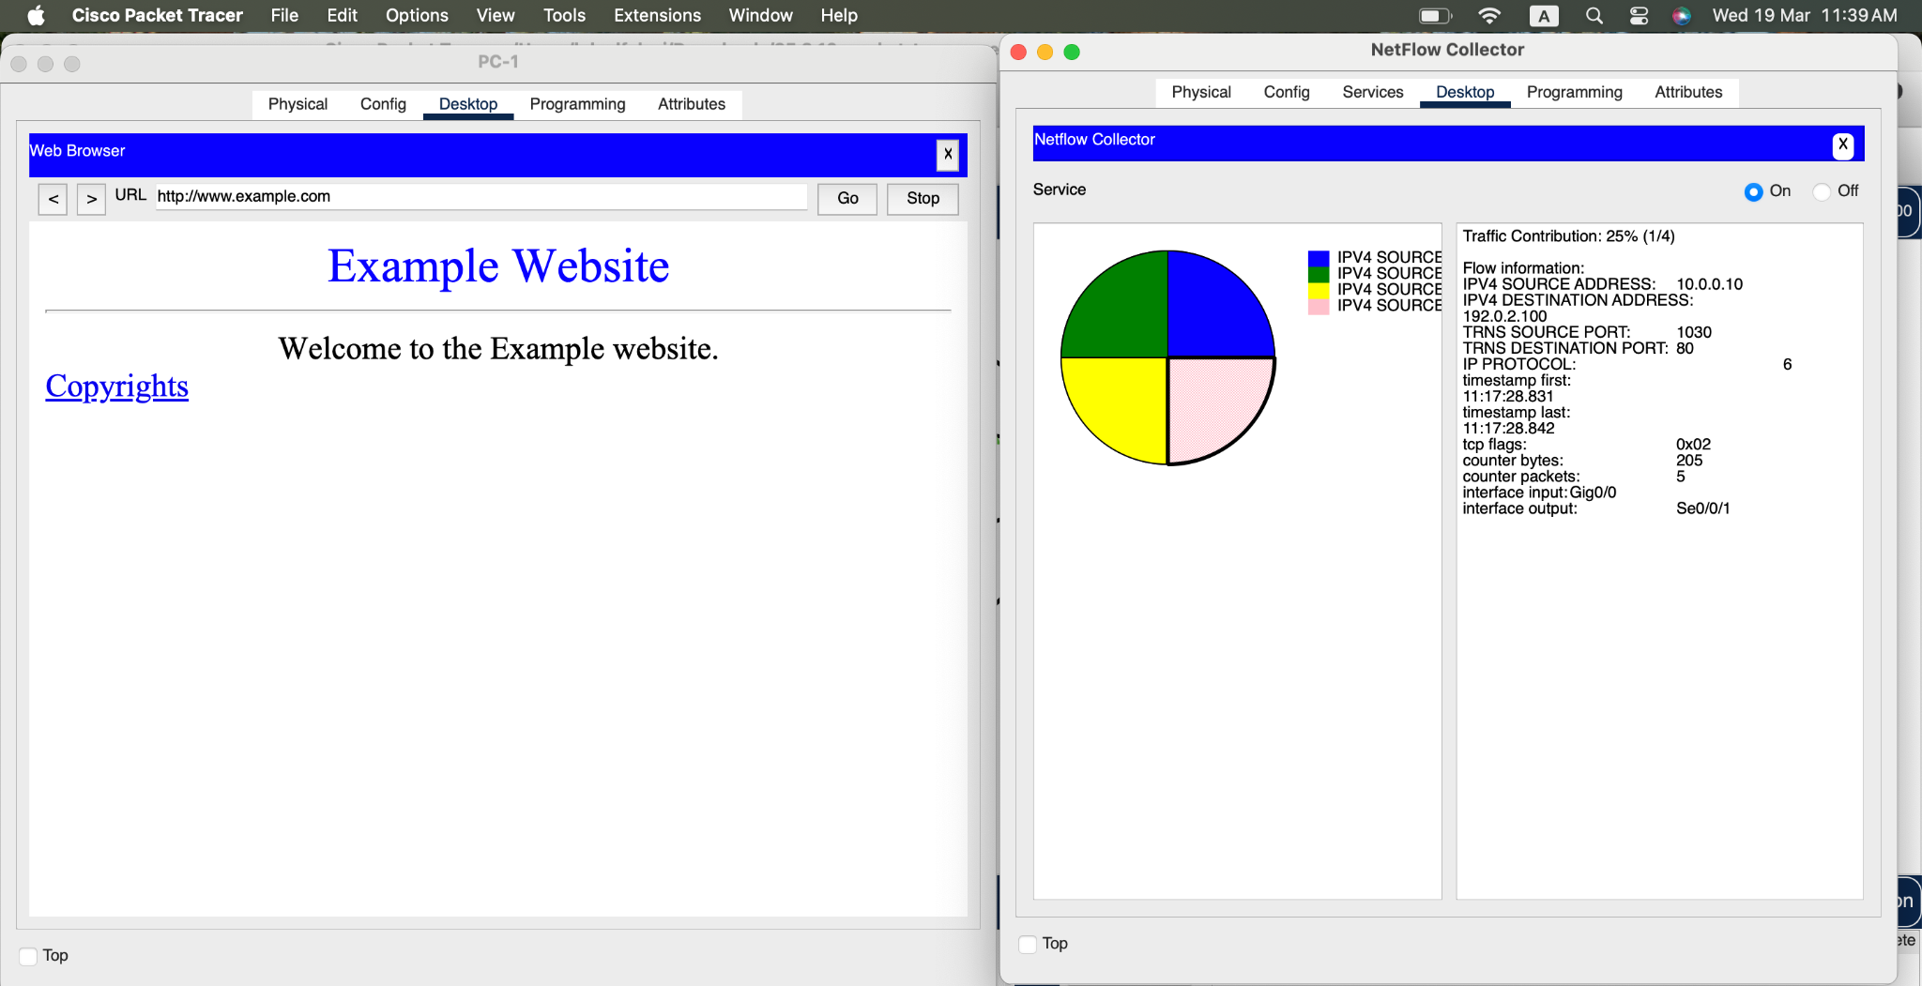

Figure 17. www.example.com piechart

e. After the flows are displayed, inspect each flow record.



Figure 18. www.example.com piechart segment 1

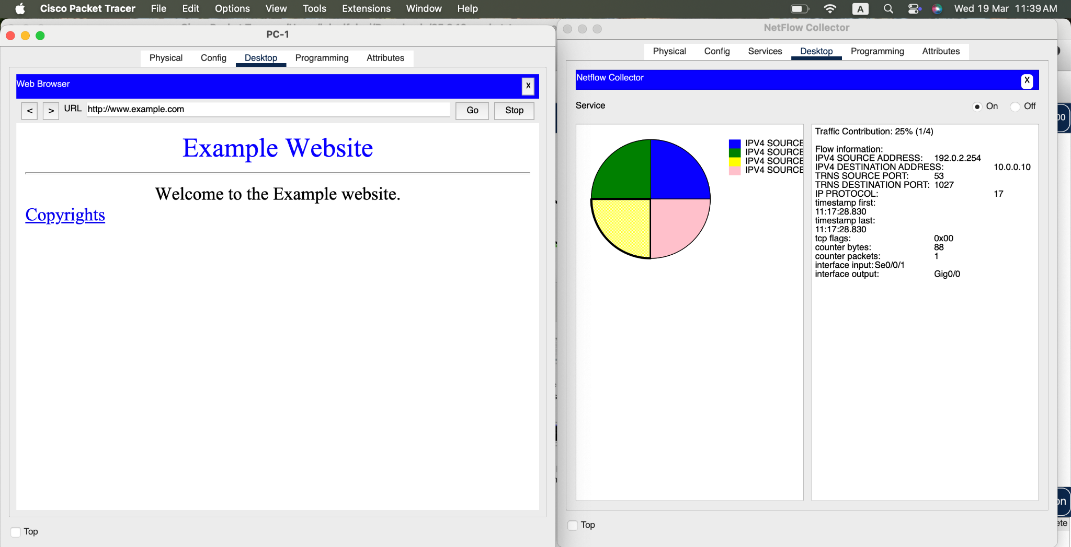

Figure 19. www.example.com piechart segment 2

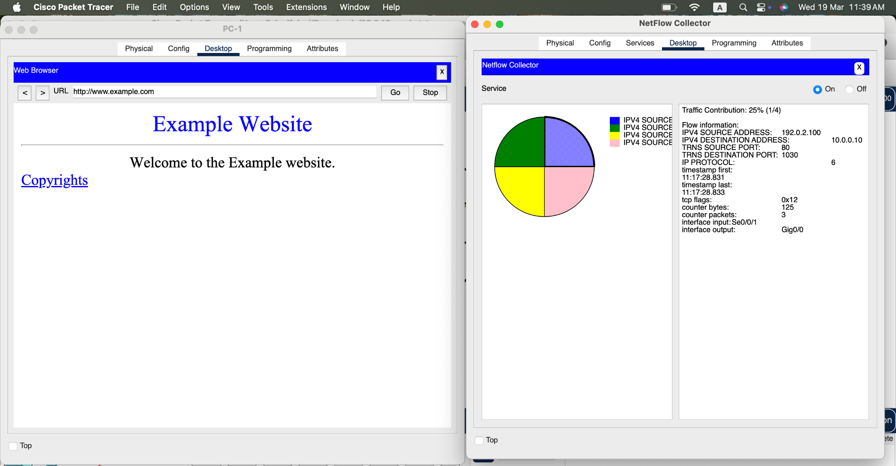

Figure 20. www.example.com piechart segment 3

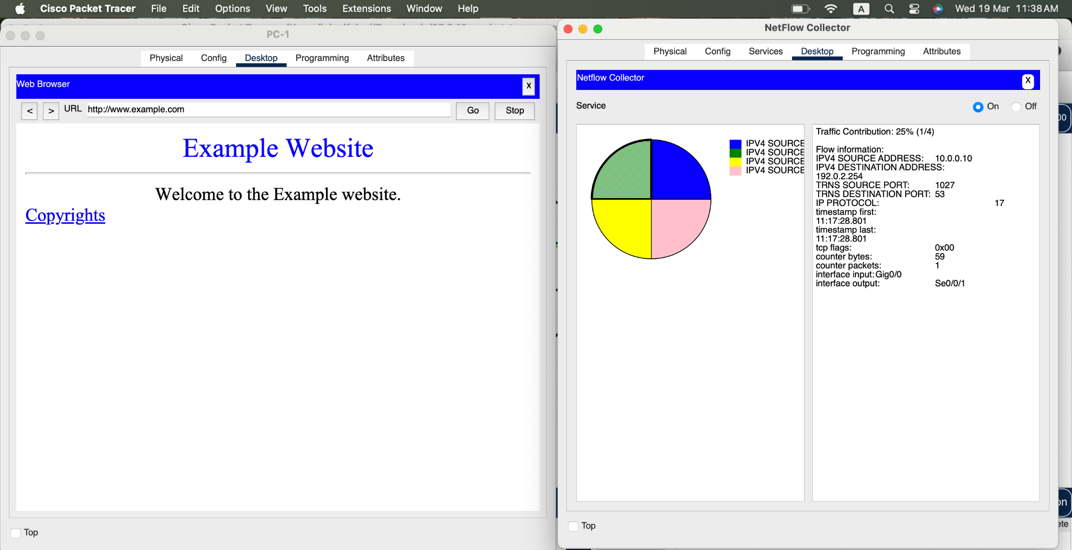

Figure 21. www.example.com piechart segment 4

#### Question:

What values do you see for the IP protocol field of the flow record? What do these values mean?

17 and 6. Protocol 6 represents TCP and covers the actual HTTP communication between PC-1 and the web server. Protocol 17 corresponds to UDP. This is for DNS traffic, specifically the DNS query and response between PC-1 and the DNS server.

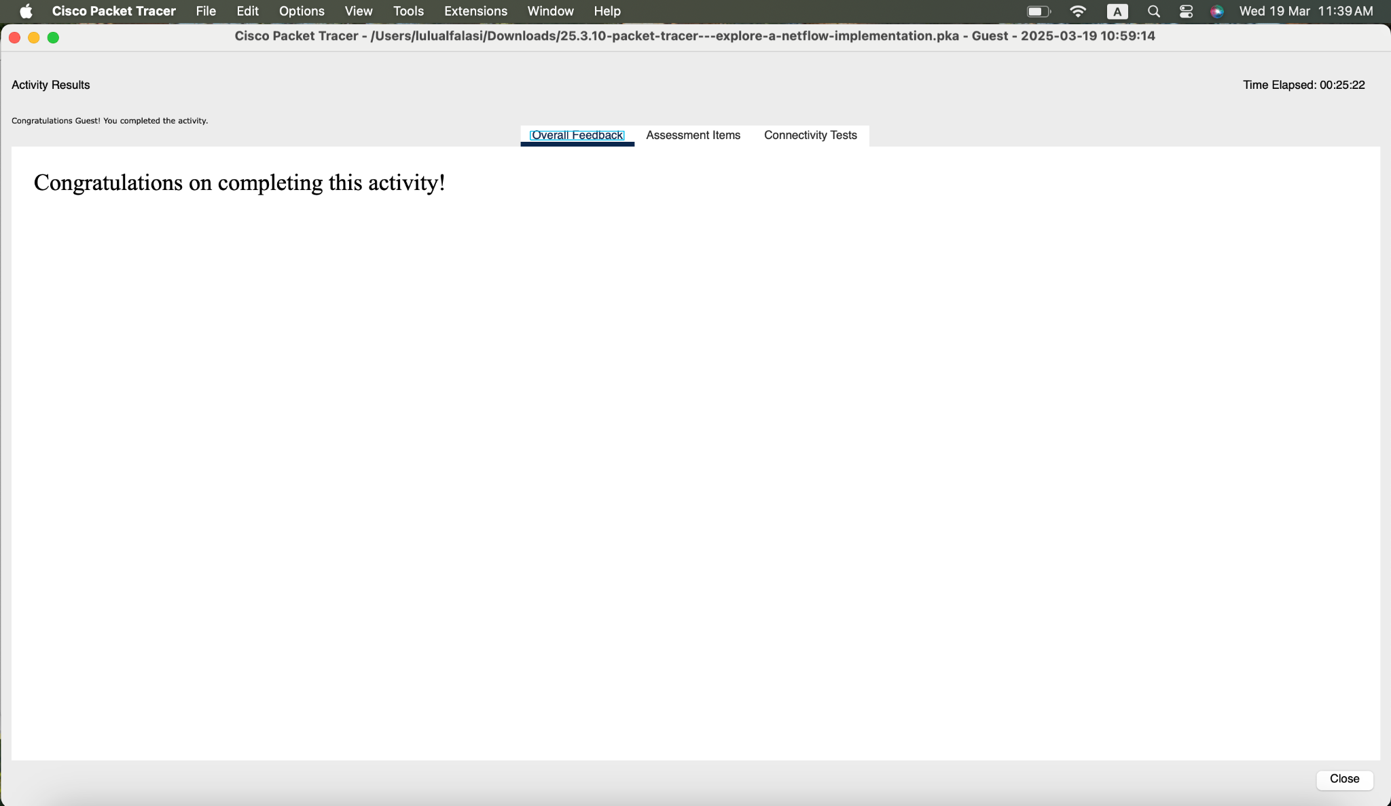

Figure 22. Verification of Completing the work